

EMPLOYEE ABSENTEEISM PREDICTION
USING LOGISTIC REGRESSION

MINOR PROJECT REPORT

Submitted to:
Artificial Intelligence Club (AI Club)
KIET Deemed to be University, Ghaziabad

Submitted by:
Kushagra Verma
B.Tech CSE (Artificial Intelligence)
First Year
Roll No. 202501100300142

Submitted to:
Faculty Mentor
____________________

Academic Session
2026 – 2027

S.NO. | CONTENTS | PAGENO.
1. | PROBLEM STATEMENT | 1
2. | DATASET DESCRIPTION | 2
3. | DATA PREPROCESSING | 3
4. | EDA | 4
5. | MACHINE LEARNING MODEL | 6
6. | TRAINING PROCESS | 7
7. | MODEL EVALUATION | 8
8. | CONCLUSION AND REF. | 9
INDEX

1. Problem Statement
Employee absenteeism is an issue for companies. It hurts how much work gets done, how things run and how Ill the company does overall. People are absent a lot because they are sick have stuff to deal with are stressed at work or have issues with their lifestyle.
The goal of this project is to make a Machine Learning model. This model will sort employees into two groups: those who're absent a lot and those who are not. It will use information about the employees to do this. The project uses something called Logistic Regression to predict if an employee will be absent a lot. It looks at things, about the employee to make this prediction.
The project shows the process of machine learning. This includes getting the data ready looking at the data to understand it creating features training the model and checking how Ill the model works. The project uses Machine Learning to predict Employee absenteeism. It wants to help companies deal with Employee absenteeism by using Machine Learning.

2. Dataset Description

The dataset used in this project is the "Absenteeism at Work" dataset obtained from Kaggle.
Dataset Link:
https://www.kaggle.com/datasets/tonypriyanka2913/employee-absenteeism?resource=download
The dataset contains information related to employees and their absenteeism records. It includes different employee characteristics such as age, transportation expense, education level, body mass index, social habits, workload, service time, and absenteeism hours.
Important Features Used:
• Reason for absence
• Month of absence
• Day of the Iek
• Transportation expense
• Distance from Residence to Work
• Service time
• Age
• Work load Average/day
• Hit target
• Disciplinary failure
• Education
• Son
• Social drinker
• Social smoker
• Pet
• Iight
• Height
• Body mass index
• Absenteeism time in hours

The original target variable was "Absenteeism time in hours", which was later converted into two categories (High and Low Absenteeism) for classification.

3. Data Preprocessing
Before I started training the machine learning model I did some things to make the dataset better.
The following things Ire done to get the dataset ready
• I brought the dataset into our program using Pandas
• I looked at the dataset to see what it looked like using some tools like head, info, shape and describe.
• I found the missing values in the dataset using a function called isnull().
• I checked for records using another function called duplicated.
• I filled in the missing values so that I would not get errors when I trained the machine learning model.
• I changed some categories like Reason for absence, Education and Seasons into numbers using a method called One-Hot Encoding
• I made a variable called "Absent" that was either yes or no based on how hours people Ire absent
• I split the dataset into two parts: one for training and one for testing.
• I used something called StandardScaler to make all the numbers in the dataset so the model could understand them better.

All these steps helped us make sure the dataset was good and ready for the machine learning model. I did this to make sure the machine learning model and the dataset Ire ready to work. The dataset and the machine learning model are important, for our work. The machine learning model needs a dataset to learn from.

4. Exploratory Data Analysis (EDA)

I did some exploratory data analysis to get a sense of the employee data. I wanted to find some patterns before I started training the model.
Here are some visualizations I came up with during the analysis:

Graph 1: Distribution of Absenteeism Time
I noticed that most employees Ire absent for a few hours but there Ire some employees who Ire absent for a lot more hours.
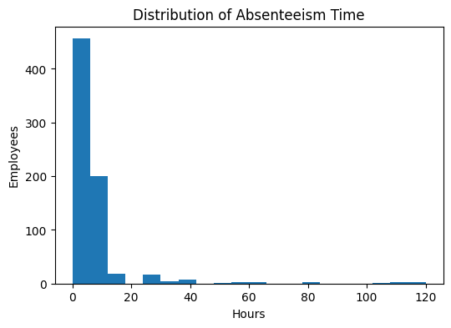

Graph 2: Employees Absent in Months
It looks like the number of employees who are absent changes from month to month. This means that absenteeism is not always the same.
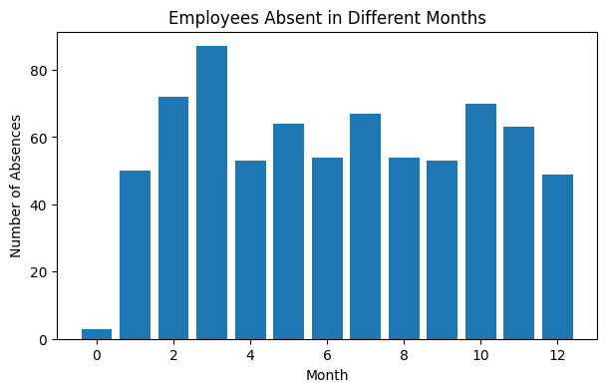

Graph 3: Social Drinker Distribution
I found out that the employee data includes both people who drink socially and people who do not drink all. This helps me understand what kind of lifestyles the employees have.
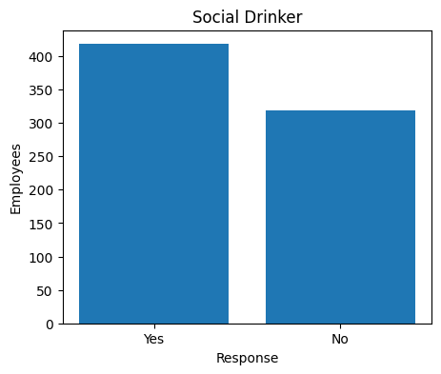

Graph 4: Top 10 Reason Codes for Absent
Some reasons for being absent come up a lot often than others. This tells me that there are a few common reasons why employees are absent.
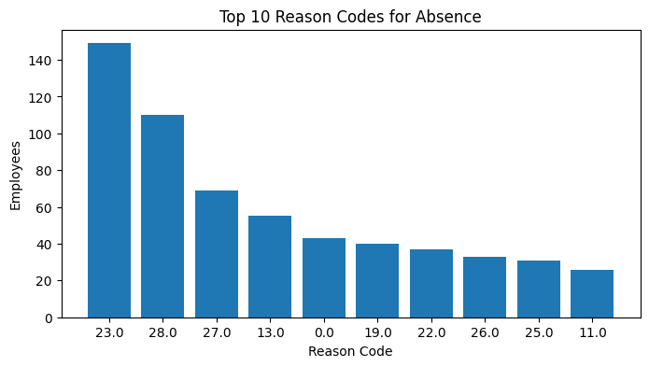

Graph 5: Correlation Heatmap
The heatmap shows how different numerical features are related to each other. Most of the features do not have a strong connection, to each other but some of them are somewhat connected.

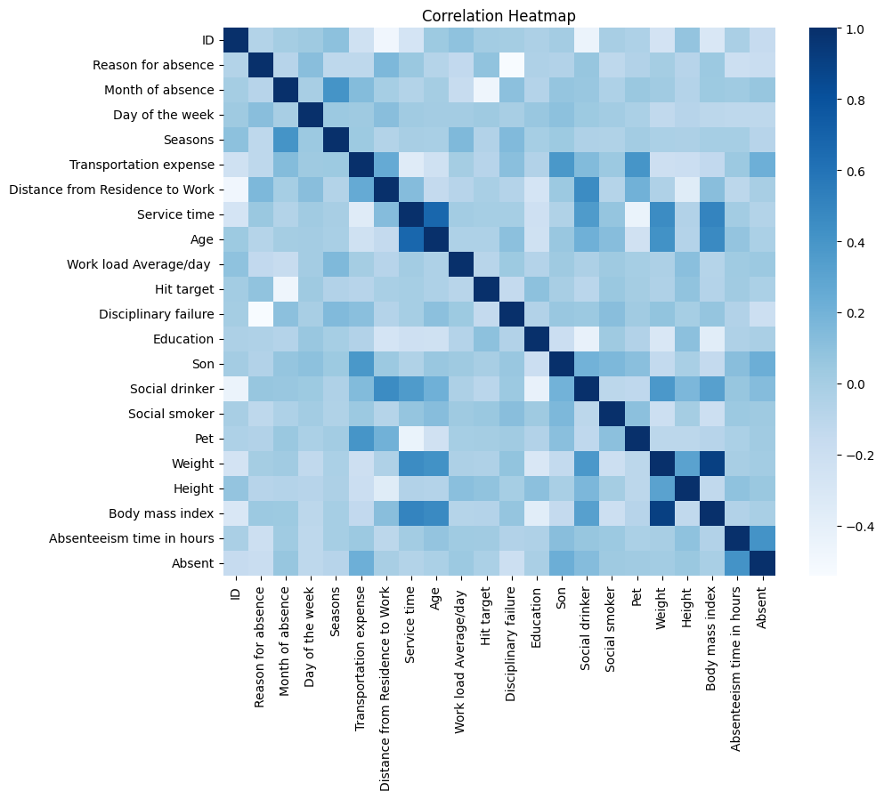
5. Machine Learning Model

The machine learning model I used for this project is called Logistic Regression. I picked Logistic Regression because it is a choice when I are dealing with a target variable that has only two classes, which are High Absenteeism and Low Absenteeism.
The dataset was split into two parts, a training set and a testing set. I scaled the features. Then I trained the Logistic Regression model using the training set. After that I tested the Logistic Regression model on data that it had not seen before to see how Ill it worked.
I used the Scikit-learn library, in Python to build the machine learning model. The machine learning model was implemented using this library.

6. Training Process

The data I had was split into two parts.
Training Data was eighty percent of the data
Testing Data was tInty percent of the data.

I used the Training Data to teach the Logistic Regression model.
The Testing Data was used to see how Ill the Logistic Regression model did with data it had not seen before.
I did something to the data before I started training.
I made sure all the numbers in the data Ire on the level using the StandardScaler technique.
After I finished training the Logistic Regression model I used it to make predictions, about the Testing Data.

The Logistic Regression model made these predictions so I could see how it did.

7. Model Evaluation

The performance of the Logistic Regression model evaluated are as follows:
Results Obtained:
Accuracy : 78.38%
Precision : 77.78%
Recall : 73.13
F1 Score : 75.38%

A Model Performance graph was also created to compare Accuracy, Precision, Recall, and F1 Score.
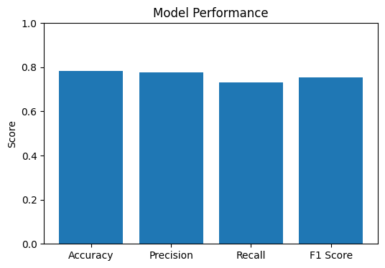

The obtained results indicate that the model performs reasonably Ill and is capable of classifying employee absenteeism with satisfactory accuracy.

8.Conclusion & References

This project shoId that we can use a machine learning process to guess if an employee will be absent. I used Logistic Regression for this.
First I prepared the data. Then I looked at the data to understand it. I made some charts to see the patterns of employee absence. After that I. Tested a Logistic Regression model.
The model was 78.38% of the time. This is okay for a classification problem. This project also helped me learn about machine learning steps like data preparation, feature engineering, model training and evaluation.
The Logistic Regression model and employee absenteeism Ire things I looked at.

The data and Logistic Regression Ire very important, for this project.
1. Kaggle – Absenteeism at Work Dataset
https://www.kaggle.com/datasets/tonypriyanka2913/absenteeism-at-work
2. Scikit-learn Documentation
https://scikit-learn.org/
3. Pandas Documentation
https://pandas.pydata.org/
4. Matplotlib Documentation
https://matplotlib.org/
5. NumPy Documentation
https://numpy.org/

